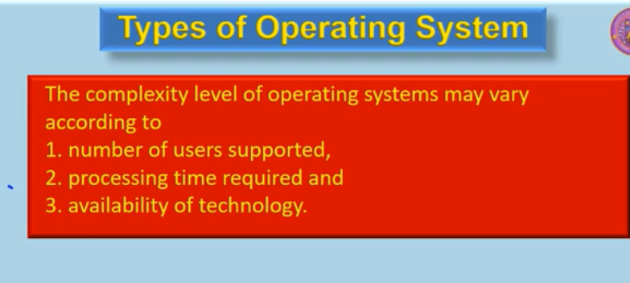

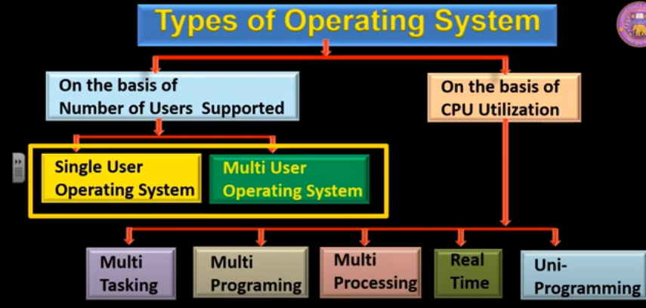

**Applications of Real Time Operating System**

Real-time systems are used in:

* Airlines reservation system.
* Air traffic control system.
* Systems that provide immediate updating.
* Used in any system that provides up to date and minute information on stock prices.
* Defense application systems like RADAR.
* Networked Multimedia Systems
* Command Control Systems
* Internet Telephony
* Anti-lock Brake Systems
* MISSILE LAUNCHING
* Heart Pacemaker

**Disadvantages of RTOS**

Here, are drawbacks/cons of using RTOS system:

* RTOS system can run minimal tasks together, and it concentrates only on those applications which contain an error so that it can avoid them.
* RTOS is the system that concentrates on a few tasks. Therefore, it is really hard for these systems to do multi-tasking.
* Specific drivers are required for the RTOS so that it can offer fast response time to interrupt signals, which helps to maintain its speed.
* Plenty of resources are used by RTOS, which makes this system expensive.
* The tasks which have a low priority need to wait for a long time as the RTOS maintains the accuracy of the program, which are under execution.
* Minimum switching of tasks is done in Real time operating systems.
* It uses complex algorithms which is difficult to understand.
* RTOS uses lot of resources, which sometimes not suitable for the system.

